Fingertip Interaction Metrics Correlate with Visual and Haptic

【Summary】：

They studied the similarities between visual and tactile perception spaces, and their relevance to fingertip interaction indicators. Twenty participants interacted with ten different real surfaces in the Penn Haptic Texture Toolkit by viewing or touching them, and judged their similarities in pairs. Our results show that the three perceptual dimensions of each mode can be expressed in terms of roughness / smoothness, hardness / softness, and friction, and these dimensions can be estimated by surface vibration power, tapped spectrum centroid and dynamic friction coefficient, respectively.

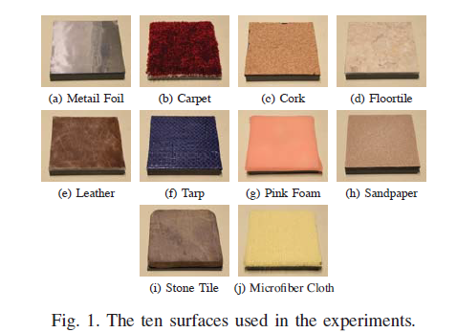 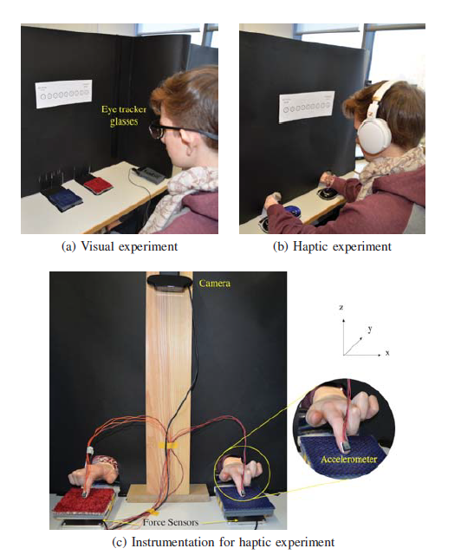

【Experiments】：

In the first experiment, participants interacted visually with the surface. In the second, participants touched the surface with their index fingers without seeing them. In physical measurements, we collected fingertip interaction data from the surface.

**Apparatus：**

We used ten surfaces from the Penn Haptic Texture Toolkit [12], which is available in our lab. As shown in Fig. 1, the selected surfaces vary in material properties, resulting in a visually and haptically diverse stimulus set. They are also robust to being touched by a human ﬁnger. Each surface is a 10.16 cm square and is mounted on a piece of acrylic using double-sided tape. The tape was placed only at the edges of the material so it does not affect the compliance of the surface. The total thickness of each sample (surface plus acrylic plate) is approximately 1.5 cm.

**Measurement Standard:**

The contact force vector, contact torque vector and finger acceleration vector were measured.

**Procedure：**

Experimental Setup and Procedure

【Conclusions】:

Our results suggest that when humans judge real surfaces using either visual or haptic cues, they perceive them simi-larly. The high correlation between average haptic and visual dissimilarities and the similar organization of the perceptual spaces show that vision and touch rely on congruent percep-tual representations (see Figs. 4 and 7). As the determined dimensions (roughness, hardness, and friction) are generally considered more prominent in the haptic modality, touch may be more dominant than vision in surface perception.

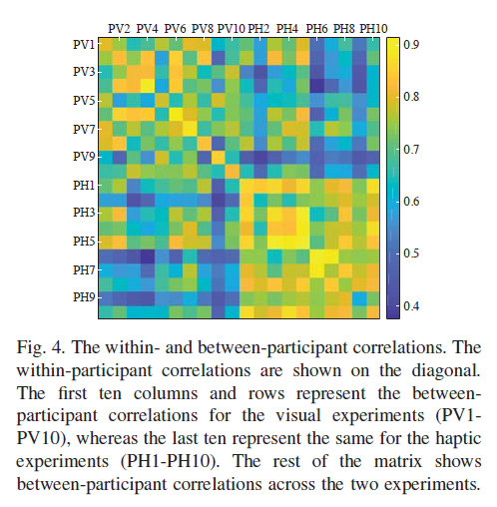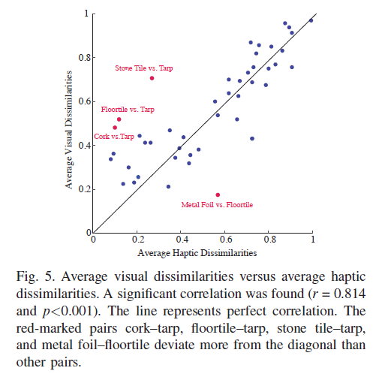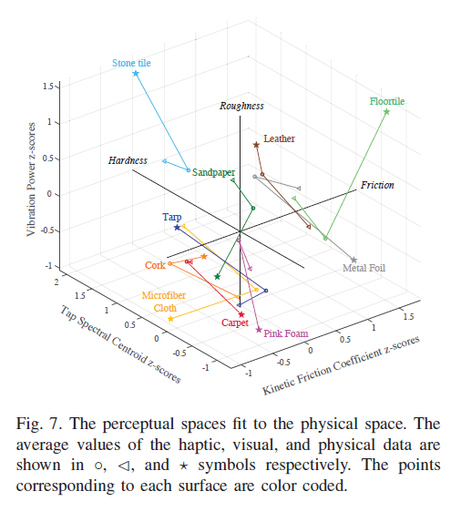

【Important Reference】:

1. M. Bergmann Tiest and A. Kappers, “Haptic and visual perception of roughness,” Acta Psychologica, vol. 124, no. 2, pp. 177–189, 2007
2. W. J. Adams, I. S. Kerrigan, and E. W. Graf, “Touch inﬂuences perceived gloss,” Scientiﬁc Reports, vol. 6, p. 21866, 2016.